**ASSIGNMENT-4**

Create email newsletter design using Mailchimp or Canva tool

|  |  |
| --- | --- |
| NAME | S.SAKTHIVEL |
| NM ID | 4F07E5A652C42CBA2034CBD38BFE3B33 |
| ASSIGNMENT 4 | Create email newsletter design using Mailchimp or Canva tool |

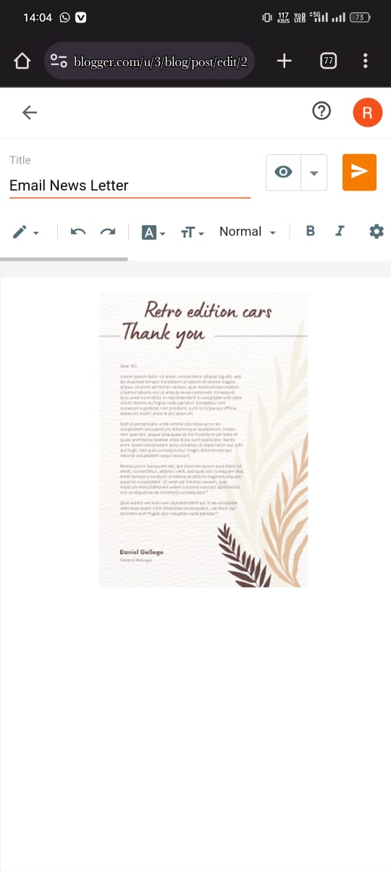

**CANVA EMAIL NEWSLETTER [LINK:https://retroeditioncar.blogspot.com/2023/10/email-news-letter.html](http://retroeditioncar.blogspot.com/2023/10/email-news-letter.html" \o "http://retroeditioncar.blogspot.com/2023/10/email-news-letter.html)**